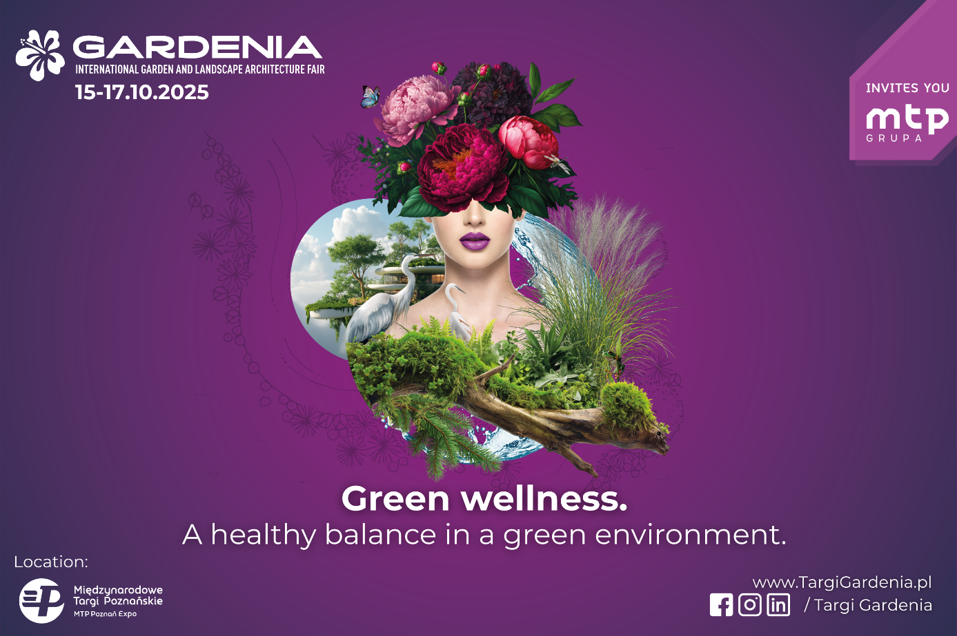

**Gardenia 2025 Fair: Poland's largest horticultural celebration this fall!**

**Ahead of us is the 19th edition of the GARDENIA 2025 International Garden and Landscape Architecture Fair, which will be held October 15-17 at the Poznan International Fair. You should already save this date in your calendar!**

# This will be the next installment of a well-known event in the industry, which this time will focus on expanding professional knowledge and presenting industry news, especially those embedded in the trend of inspiring environmentally friendly solutions. This is one of the most important industry events in Poland and Europe, which every year attracts plant enthusiasts, experts and entrepreneurs from the horticultural sector. Gardenia will continue in the fall term i.e. October 15-17 in pavilions 7, 7A, 8 and 8A at the Poznań International Fair.

**News and attractions of Gardenia 2025**

The organizers have prepared many novelties that will make this year's edition unique. Among them, the Speaker's Corner, as well as the Novelty Zone deserve special attention.

**Speaker's Corner is a lecture and training zone.**

This space will host specialized training sessions on sales and marketing in the horticultural industry. Each day will be devoted to a different topic, and experts will share their knowledge on how to successfully grow a gardening business. The culminating event in this zone will be a sales and marketing training conducted by the Polish Association of Garden Centers. Speaker's Corner is a space where practice meets theory, and participants leave not only with new knowledge, but also with real ideas for developing their business.

**News Zone - Discover the most exciting plant launches!**

# This year's Novelty Zone at Gardenia 2025 is an absolute must-see for all plant enthusiasts and gardening trends! It is a unique space where visitors will have the opportunity to see 10 plant novelties that have never before been presented in Poland. The zone will be a kind of “botanical premiere” - a place where professionals, enthusiasts and buyers will be able to discover the freshest plant trends that are likely to dominate gardens, parks and green spaces in the coming years. The Novelty Zone is not only about unique varieties that can revolutionize gardening, but also about access to plants from leading European breeders that can contribute to new possibilities for garden and urban landscaping. If you want to stay abreast of the hottest horticultural trends plan your visit to Gardenia Fair now and immerse yourself in the world of plant innovations.

**In the program of events**

**Urban Garden Art - A forum for urban greening experts.**

The Gardenia 2025 Fair will feature the 19th edition of the "Urban Garden Art" Forum, organized by Urban Greening magazine (ABRYS) and the Gardenia Fair. This is one of the most important meetings dedicated to greenery managers, urban planners, landscape architects and urban activists who deal with the design and maintenance of vegetation in public spaces. The Urban Garden Art Forum is a place where knowledge meets passion for urban greenery. If you are interested in landscape architecture, ecology and the future of greenery in cities, this event is a must-attend at Gardenia 2025!

**Championship of Polish Florists "COLORS OF FREEDOM" - a unique display of creativity and floral art!**

During Gardenia 2025, one of the most prestigious events in the floral industry will take place - the "Colors of Freedom" Polish Florist Championships. Organized in cooperation with the Association of Polish Florists, this championship will be full of artistic challenges, competition at the highest level and unforgettable floral compositions. The only florist competition of its kind in Poland - participants will face three days of competition, presenting their skills in creating stunning floral arrangements. The main theme: "Colors of Freedom" - the theme of the championship emphasizes the importance of creative freedom and diversity of compositions, inspiring participants to interpret the theme in their own unique way. Competition of the best florists - the competition attracts both Polish and foreign experts who present innovative techniques and unique approaches to the art of floristry.

**Demonstration Garden under the theme “Illusion in the Garden”-an inspiration for every greenery lover!**

The Show Garden organized by the National Association of Garden Designers is one

of the most spectacular attractions of the Gardenia 2025 Fair. It is a space where garden art meets modern design and ecological solutions. Visitors will have the opportunity to see the latest trends in green design, discover innovative technologies used in gardens and admire unique compositions created by experts. The Show Garden is not only a presentation of the latest trends but also an inspiration for your own projects whether you have a garden, balcony or terrace.

**Certified training of the Federation of Polish Arborists - professional education for the horticultural industry**

During Gardenia 2025, the Certified Training of the Federation of Polish Arborists will be held, providing an excellent opportunity to improve skills in the horticultural industry. This event is aimed at professionals who want to gain practical knowledge and official confirmation of their skills.

**Florist stage - rich program for three days**

Floristry is an extremely dynamic and inspiring field, and the Florist Stage at Gardenia 2025 will become a place where floral art will be celebrated in the most beautiful way. Attendees will have the opportunity to immerse themselves in the world of colors, compositions and floral techniques, admiring demonstrations, taking part in workshops and gaining valuable knowledge from masters of this art. On the florist stage, floral demonstrations are planned by the best florist masters, who will present their skills in spectacular shows, during which they will create unique floral arrangements. In addition, the organizers are preparing workshops and training courses and lectures, which will be conducted by industry experts giving the opportunity to gain valuable knowledge that can be used in business and creative work.

**International dimension of Gardenia 2025 - global business opportunities**

Gardenia 2025 is not only the largest horticultural fair in Poland, but also an important international event that attracts industry representatives from all over the world. The organizers are placing special emphasis this year on foreign visitors, who will include sales directors, buyers, purchasing directors and presidents of garden centers, retail chains, wholesalers and plant nurseries. Visitors will come mainly from France, Italy, Lithuania, Latvia, the Czech Republic, Slovenia, Slovakia, Romania, Albania, Bulgaria, Croatia, Montenegro and the United Kingdom. The fair will also host buyers from China interested in directly buying plant material from Poland.

**Hosted Buyers Program - strategic business meetings.**

One of the key elements of the international dimension of Gardenia 2025 is the Hosted Buyers program, which is designed to facilitate face-to-face meetings between exhibitors and key buyers from abroad. The Hosted Buyers program is a unique opportunity to make valuable business contacts and increase your international presence in the horticultural market. If you want your business to grow on a European and global scale, participation in this program is the key to success!

# Gardenia and POLECO - greenery and ecology shoulder to shoulder

**POLECO trade fair October 14-16 - the most important event for the environmental protection and municipal management industry.**

POLECO is the largest and most important trade fair in Poland dedicated to environmental protection, municipal management and sustainable development. It is a place where experts, representatives of legislative institutions, local governments and business meet to exchange experiences and present innovative solutions for better management of urban space and ecology. POLECO brings together representatives of public institutions, entrepreneurs and experts who have a real impact on shaping environmental policy in Poland and Europe. At the fair you can see the latest technologies related to waste management, renewable energy sources and green infrastructure, as well as participate in a rich program of debates, lectures and panel discussions on key environmental challenges.